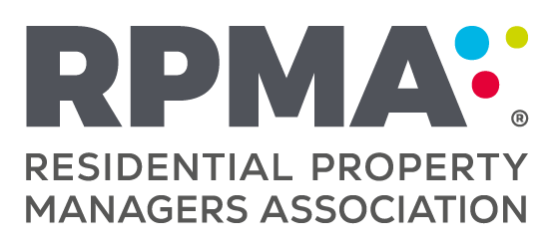
RESIDENTIAL PROPERTY MANAGERS ASSOCIATION OF NEW ZEALAND INCORPORATED

Notice of Annual General Meeting

TAKE NOTICE that the Annual General Meeting of the Residential Property Managers Association of New Zealand will be held:

Online
3:30pm Wednesday 2nd August 2023

This year, there are three positions available for election to the RPMA Council. Three members of the Council are required to retire each year. The members retiring are eligible to be re-nominated in line with the normal process.

If you would like to nominate a current member of RPMA, to the Council, please complete the 1596_rpma_Council_Nomination_Form.pdf
and return to RPMA in time to be received by 3.30pm Wednesday 5th July 2022.

EMAIL: admin@rpma.org.nz or
POST: Residential Property Managers Association
16 Liverpool Crescent, Hastings 4120

Information on eligibility for the Board, meeting procedures and voting can be found under
Rule 9 of the The RPMA® Constitution » Residential Property Managers Association of New Zealand

Any member nominated for the Council should send a headshot photo (jpg format) and a maximum 150-word personal profile to admin@rpma.org.nz. This must be receipted at the RPMA office by 3.30pm Wednesday 5th July 2023. This material will be circulated to members via the Geeco Election Module.

We look forward to receiving your nominations.

Yours sincerely
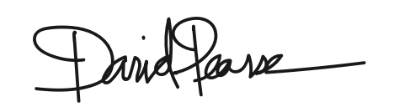

David Pearse QRPM
Chairperson

